Bridging World History. Unit 5. Early Belief Systems
Source: http://www.learner.org/vod/vod_window.html?pid=2148
Shinto
Animism
Supernatural
Shamans
Greece
Homer
Philosophia (wisdom)
Socrates
Human Reason
Just society
Zeus
Confucius
Warring States
Zhou
Divine sanction for political order
Analects
Social harmony
Social order
Hinduism
Vedas
Upanishad
Brahman
Buddhism
Dharma
Karma
Struggle between good and evil
Zoroastrianism
Judaism
Christianity
Israelites
Central idea of God
Muslims
Trinity
Monotheistic

Unit 7. The Spread of Religions
Source: http://www.learner.org/vod/vod_window.html?pid=2150
Buddhism, Christianity, and Islam
- When and where did these three religions begin?
- Name the main elements that contributed to the spread of these religions.
- What is Buddhism about?
- What was the original language Buddhist teachings were recorded in?
- What was needed to spread the word of Buddhism?
- What is the significance of The Journey to the West?
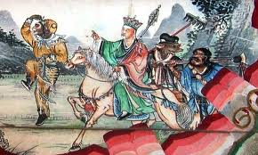
- What did the Greek Orthodox believe about other religions?
- Why did Christianity experience resistance in its early stages?
- Which Roman emperor converted to Christianity and why?
- Who was Helena?
- Describe Charlemagne’s importance in helping spread Christianity.
- How was Charlemagne rewarded for his efforts?
- Where is Mecca?
- What is a pilgrimage?
- Who was Muhammad and what happened to him?
- What does “Islam” mean?
- Why was Islam appealing to many people?
- How did merchants spread Islam?
- What are the Five Pillars of Islam?
- Explain Sufism.
- What are other ways of spreading religions besides through trade?
- What is diaspora?

